Convex Optimization for Data Science
Gasnikov Alexander, Tremba Andrey
Merkulov Daniil (t.a.)
daniil.merkulov@skolkovotech.ru

Lecture 2. Convex optimization and Big Data applications

SkolTech
October – December 2016.
Main books:

Nemirovski A. Lectures on modern convex optimization analysis, algorithms, and engineering applications. – Philadelphia: SIAM, 2013.

Nesterov Yu., Shpirko S. Primal-dual subgradient method for huge-scale linear conic problem // SIAM Journal on Optimization. – 2014. – V. 24. –no. 3. – P. 1444–1457.

Bubeck S. Convex optimization: algorithms and complexity // In Foundations and Trends in Machine Learning. – 2015. – V. 8. – no. 3-4. – P. 231–357.

Blum A., Hopcroft J., Kannan R. Foundations of Data Science. Draft, June 2016.
http://www.cs.cornell.edu/jeh/book2016June9.pdf

Gasnikov A. Searching equilibriums in large transport networks. Doctoral Thesis. MIPT, 2016.
https://arxiv.org/ftp/arxiv/papers/1607/1607.03142.pdf

http://www.maths.ed.ac.uk/~prichtar/
Structure of Lecture 2

- Google problem (Page Rank)
- Inverse problems: traffic demand matrix estimation from link loads
- Empirical Risk Minimization (ERM)
- Maximum Likelihood Estimation (MLE)
- Bayesian inference
- L1-optimization (sparse solution)
- Typical Data Science problem formulation (as optimization problem)
- Dual problem
- Traffic assignment problem
- Truss topology design
Google problem (Page Rank)
Let there are 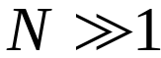 users that independently walk at random on the web-graph (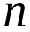 vertexes). Assume that transitional probability matrix of random walks  is irreducible. Let’s denote 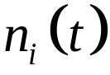 – the number of users at the -th web-page at the moment of time . Using Gordon–Newell’s theorem one can obtain 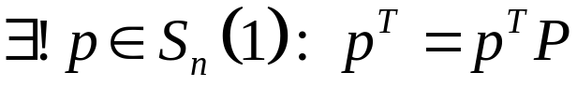 (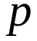 – Page Rank) and
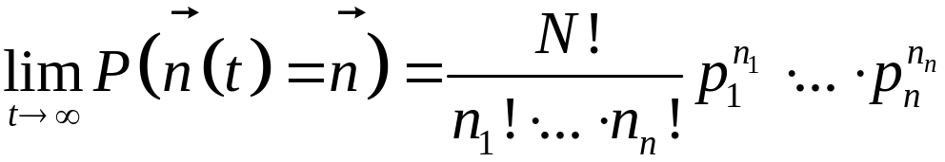.
Hence, using Hoeffding’s inequality in a Hilbert space one can obtain
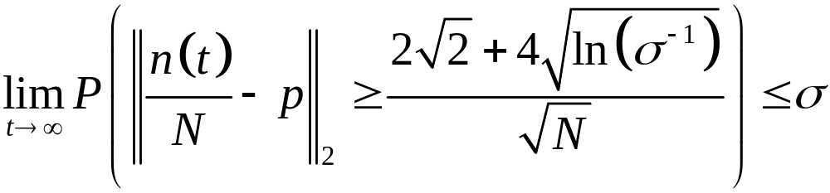.
How to find Page Rank via Convex Optimization?
According to Frobenius’ theory for nonnegative matrix we have the following equivalent optimization’s type reformulations of Google problem:
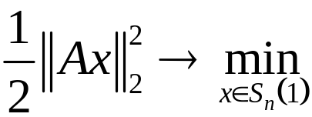; (smooth representation)
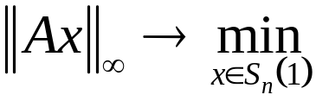; (not smooth representation)
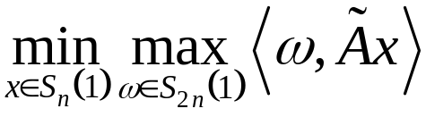; (saddle point representation)
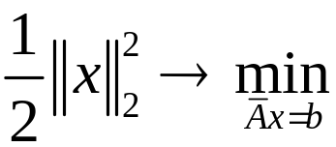, (required dual representation)
where 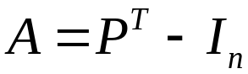, 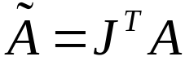, 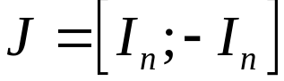, 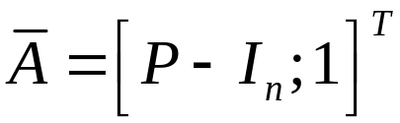, 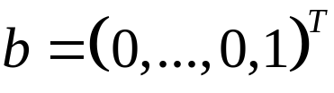.
Inverse problems: traffic demand matrix estimation from link loads
In the problem of traffic demand matrix estimation the goal is to recover traffic demand matrix represented as a vector 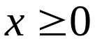 from known route matrix  (the element 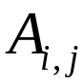 is equal 1 iff the demand with number  goes through link with number and equals 0 otherwise) and link loads 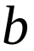 (amount of traffic which goes through every link). This leads to the problem of finding the solution of linear system 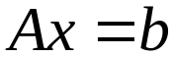. Also we assume that we have some 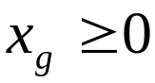 which reflects our prior assumption about 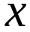. Thus we consider to be a projection of 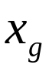 on a simplex-type set 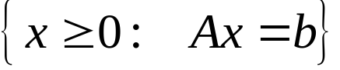
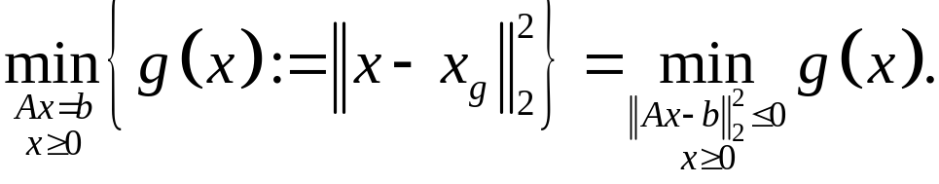
Slater’s relaxation of this problem leads to the problem (denote 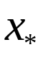 the solution of this problem)
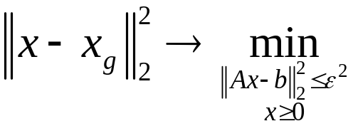.
This problem can be reduced to the problem (unfortunately without explicit dependence 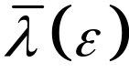)
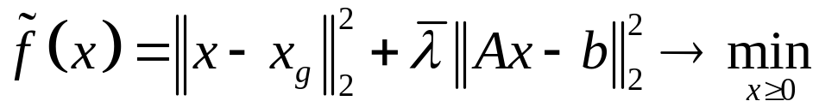,
where 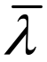 – dual multiplier to the convex inequality 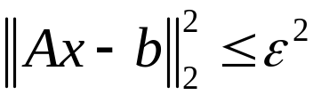.
One might expect that 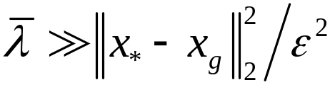, but in reality can be chosen much smaller (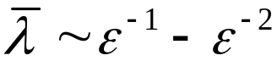) if we restrict ourselves only by approximate solution. Let’s reformulate the problem
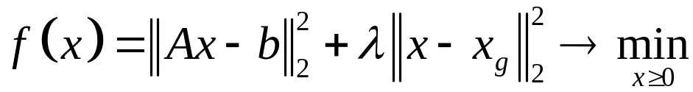,
where 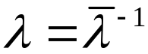. But sometimes it is worth to consider more general cases:
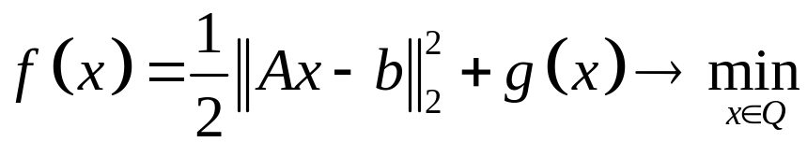.
Hastie T., Tibshirani R., Friedman R. The Elements of statistical learning: Data mining, Inference and Prediction. Springer, 2009.
Possible variants for choosing 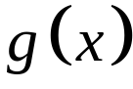 are:
- (Ridge Regression / Tomogravity model)
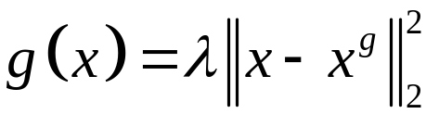, 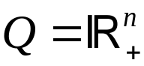;
- (Mimimal mutual information model)
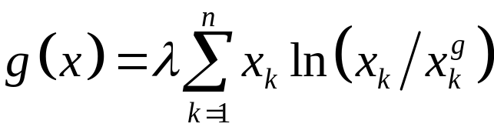, 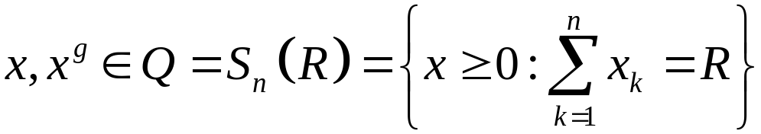.
- (LASSO)
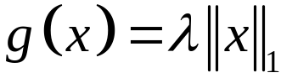, ;
Empirical Risk Minimization (ERM)
Suppose we have observation 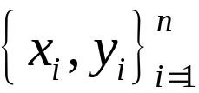 and we have some loss function 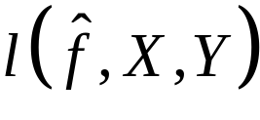. For example,
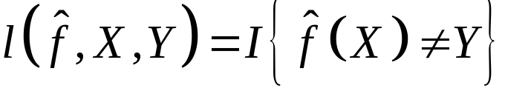 – binary classification;
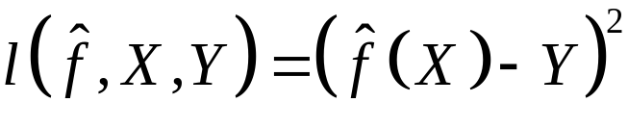 – regression;
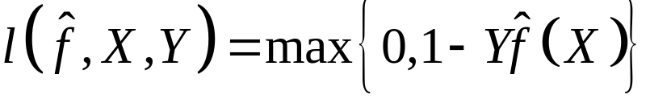 – hinge loss.
Let’s introduce 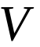 – -dimension of class 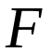,
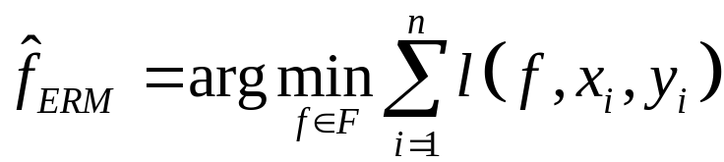, 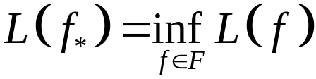,
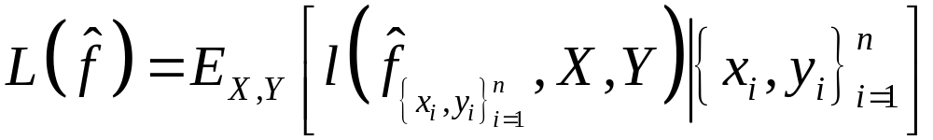, for 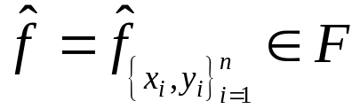.
Then (Vapnik–Chervonenkis, Zauer, Hausler for binary classification)
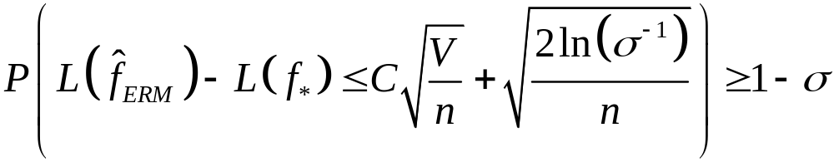,
where  is universal constant.
Now Statistical Learning Theory (SLT) is a big branch of research where ERM approach (and its penalized versions) is the main tools.
Shalev-Shwartz S., Ben-David S. Understanding Machine Learning: From theory to algorithms. Cambridge University Press, 2014.
Sridharan K. Learning from an optimization viewpoint. PhD Thesis, 2011.
Maximum Likelihood Estimation (Fisher, Le Kam, Spokoiny)
Let 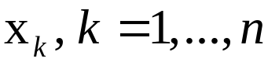 – i.i.d. with density function 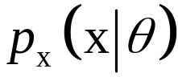 (supp. doesn’t depend on ), depends on unknown vector of parameters . Then for all statistics 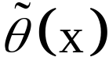 (with 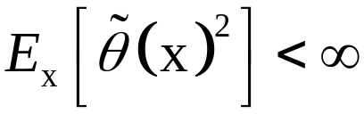):
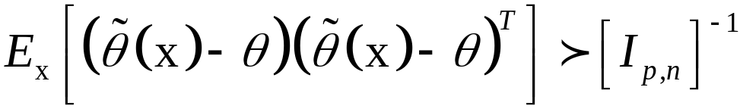, (Rao–Cramer inequality)
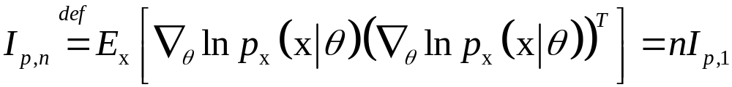,
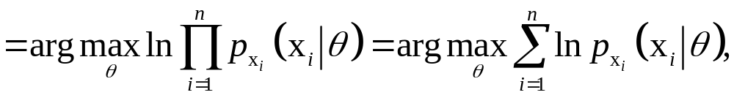
Le Kam theory (Fisher’s theorem): When 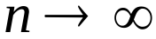 then 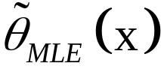 is asymptotically normal and optimal in sense of Rao–Cramer inequality (“=”).
Recently V. Spokoiny’ve proposed non asymptotic variant of this theory. In particular his theory allows to answer for the question: how fast could  (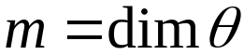 ) with for asymptotic optimality of 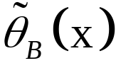. He also considered closely connected result – Wilks’ phenomenon.
Example (Least Squares). 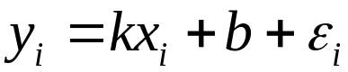 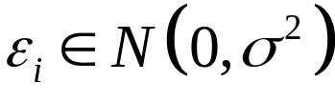, 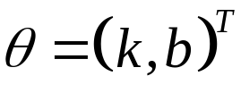,
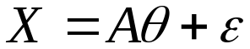, 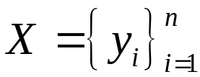, 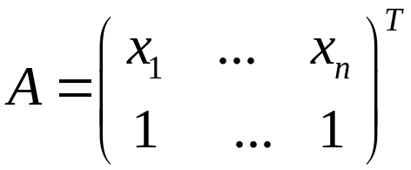, 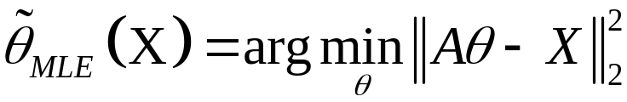.
Van Trees inequality (generalization of Rao–Cramer inequality)
Let – i.i.d. with density function (supp. doesn’t depend on ), depends on unknown vector of parameters with prior distribution 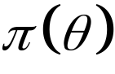. Then for all statistics (with ):

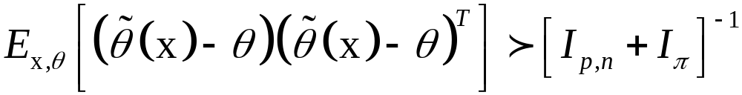, (*)
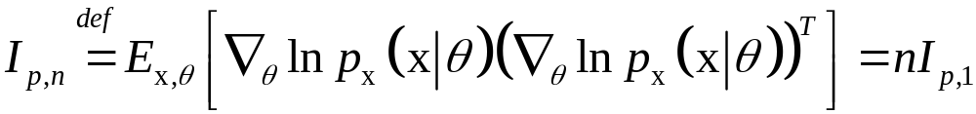, 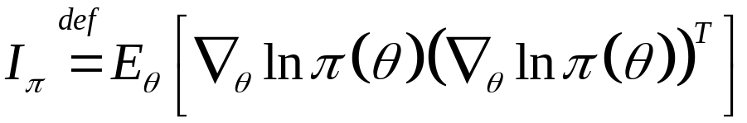.
Bayesian inference
Bayesian estimation:

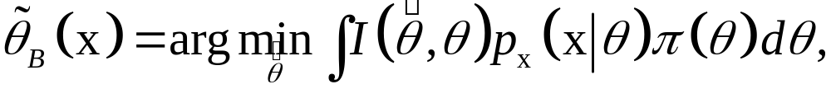
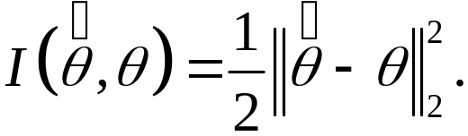
Le Kam theory: When then is asymptotically normal and optimal in sense of (*) (“=”).
Recently V. Spokoiny’ve proposed non asymptotic variant of this theory. In particular his theory allows to answer for the question: how fast could ( ) with for asymptotic optimality of .
Van Trees inequality 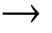 Rao–Cramer inequality and when 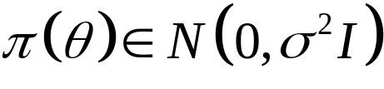 with .
Berstein–von Mises theorem say that is 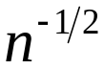-normaly concentrated around when . Recently V. Spokoiny’ve proposed non asymptotic variant of this theorem.
Example. Assume that
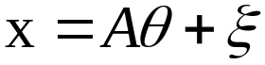, 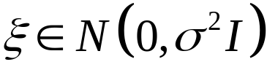, prior on 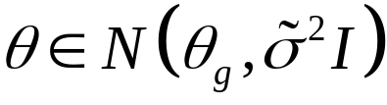
Then (compare to the traffic demand matrix estimation problem)
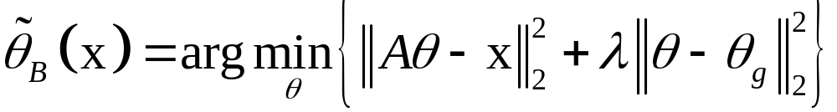, 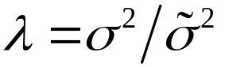.
Compressed Sensing and L1-optimization (Donoho, Candes, Tao)
There are many areas where linear systems arise in which a sparse solution is unique. One is in plant breading. Consider a breeder who has a number of apple trees and for each tree observes the strength of some desirable feature. He wishes to determine which genes are responsible for the feature so he can cross bread to obtain a tree that better expresses the desirable feature. This gives rise to a set of equations where each row of the matrix corresponds to a tree and each column to a position on the genome. The vector corresponds to the strength of the desired feature in each tree. The solution tells us the position on the genome corresponding to the genes that account for the feature. So one can hope that NP-hard problem 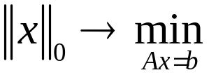 can be replaced by convex problem 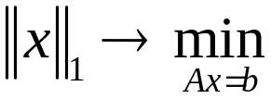. Due to Lagrange multipliers principle we can relax this problem as
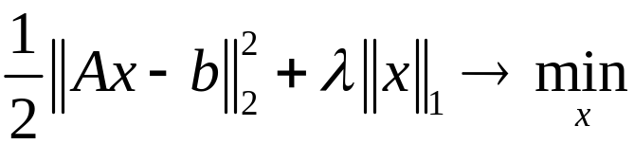.
What are the sufficient conditions for:  ?
Restricted Isometry Property (RIP)
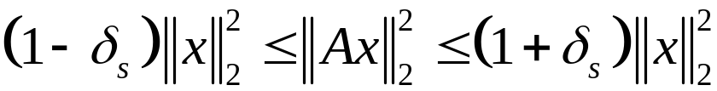 for any 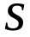-sparse .
Sufficient condition. Suppose that 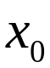 (solution of ) has at most nonzero coordinates, matrix satisfy RIP with 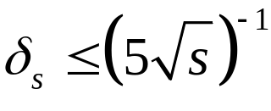, then is the unique solution of the convex optimization problem .
Example RIP matrix: for all 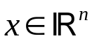 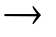 , where i.i.d. 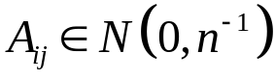 (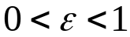). If  is 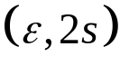-RIP and 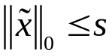 satisfy 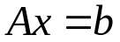 then 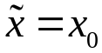.
Examples of Data Science problems
Typically Data Science problems lead to the optimization problems:
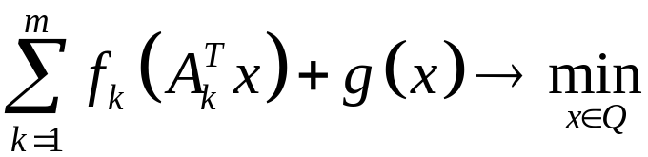.
At least one of the dimensions is huge 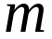 (sample size), (parameters).
Ridge Regression
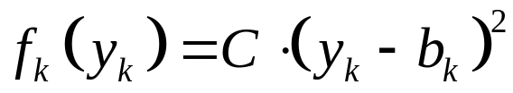, 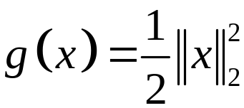. (smooth, strictly convex)
Support Vector Machine (SVM has Bayesian nature, V.V. Mottl’)
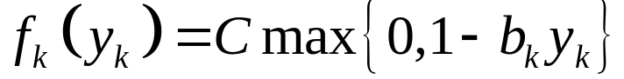, . (non smooth, strictly convex)
Dual problem (convex case)
Sometimes it is proper to solve dual problem instead of primal one:
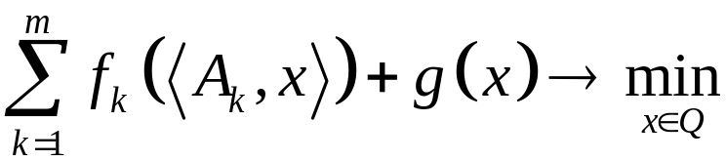,
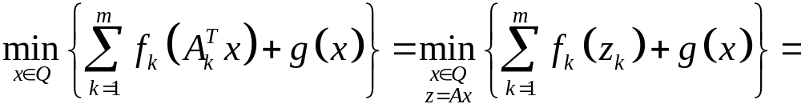
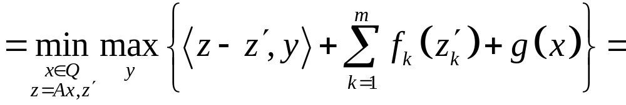
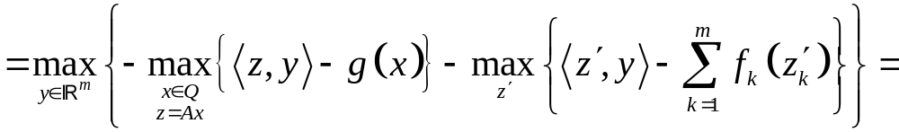
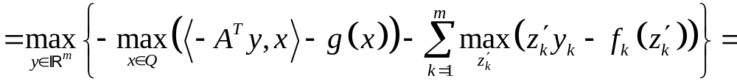
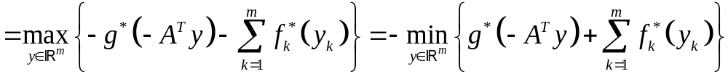.
- 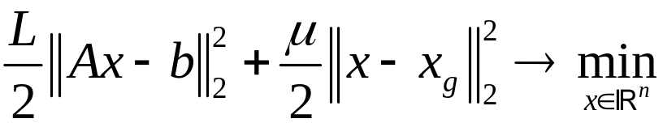, 2) 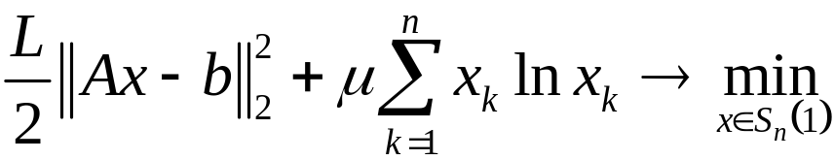.
- 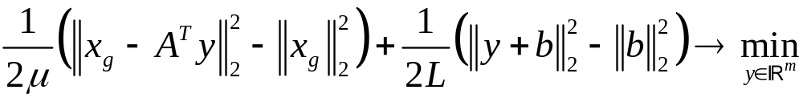, (dual for 1))
- 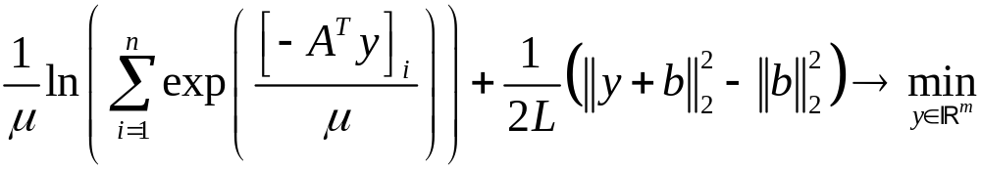. (dual for 2))
Good and Bad News
Good news: In convex case even with huge and these type of the problems
are fast solvable numerically (often by accelerated primal or dual coordinate descent methods – see Lecture 8).
Bad news: Real Data Science problems often lead to non convex optimization problems. Typical example is probabilistic topic modeling (see K.V. Vorontsov). With MLE-approach one can obtain only non convex problem
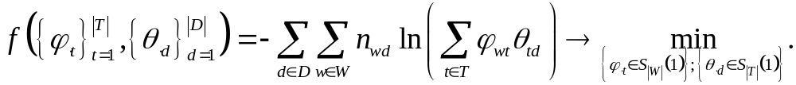
To find traffic assignment one has to solve convex optimization problem

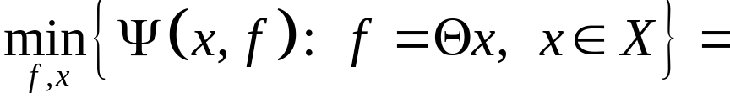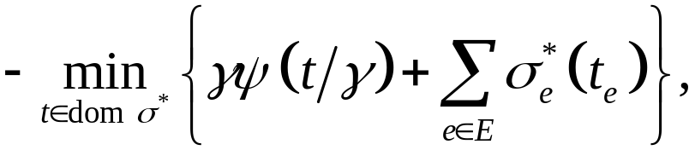
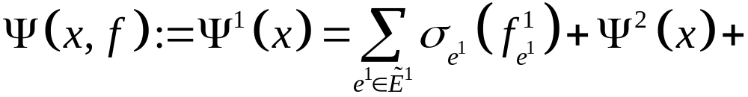
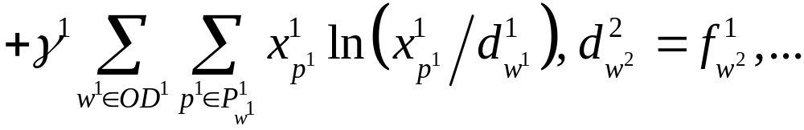
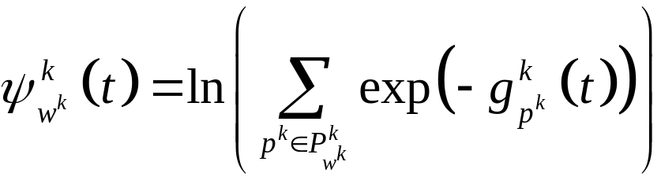, 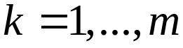, 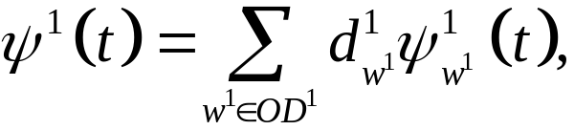
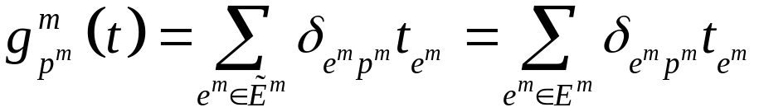,
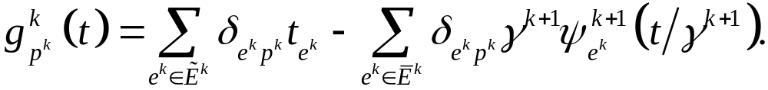
Braess paradox (BMW-model, 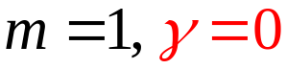)
Up
f/100
45

Start
Finish
0

Down
f/100
45

Demand: 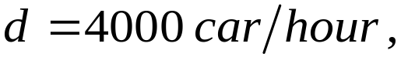 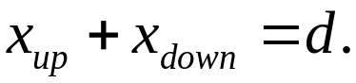
Equilibrium: 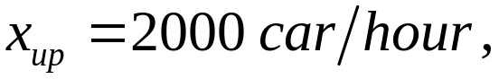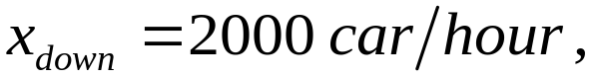
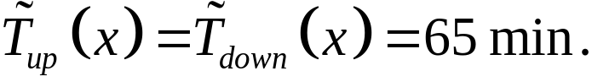
Equilibrium (if exists edge Up->Down): 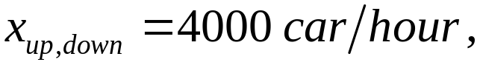
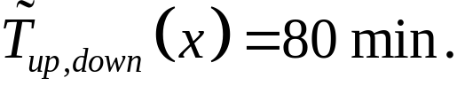

Braess paradox (BMW-model, )
Up
f/100
45

Start
Finish
0

Down
f/100
45

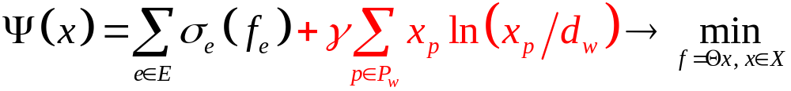, 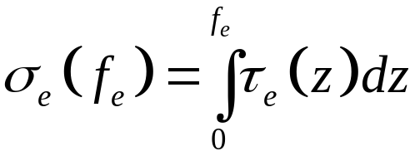. (*)
Road pricing: 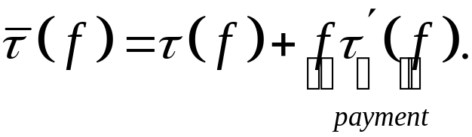 (VCG –mechanism);
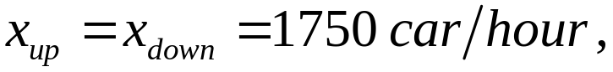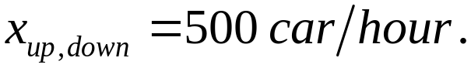
Braess paradox (Stable Dynamic model, 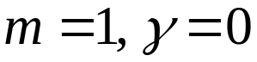)

222
322
122

Demand:
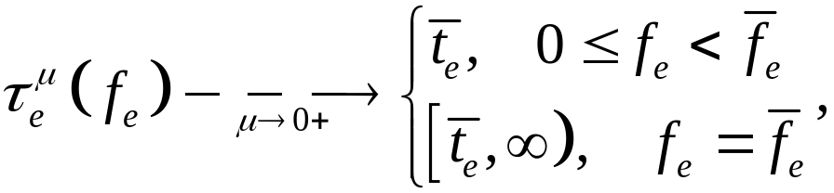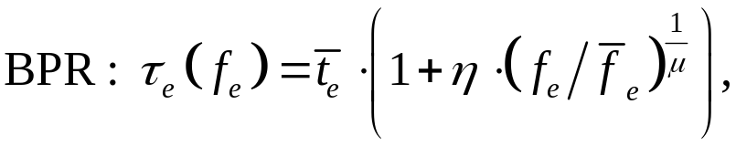
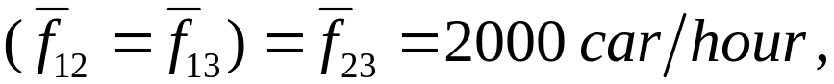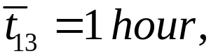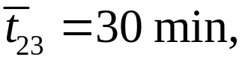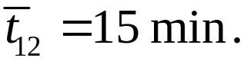
Equilibrium (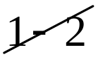): 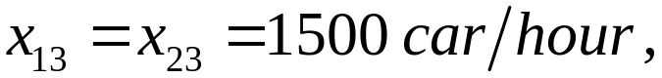 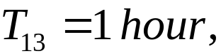 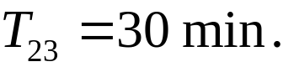
Equilibrium (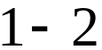): 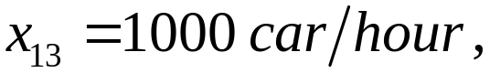 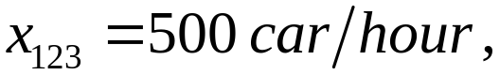
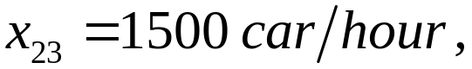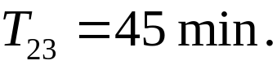
If in (*) we go to the limit 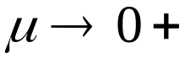, then: 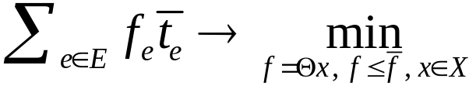.
Entropy model for demand matrix calculation (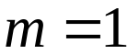)

2
3
1
2
O
D

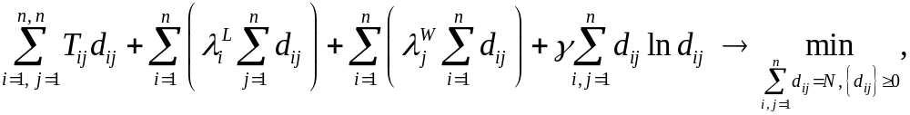
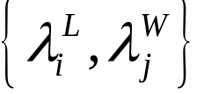 – “attractive potentials” of districts (Kantorovich–Gavurin).
Unfortunately, we don’t know potential. But we know such 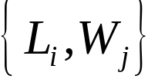, that
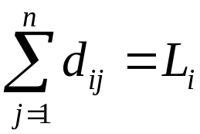, 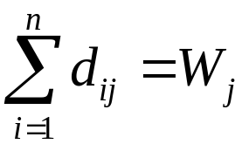 (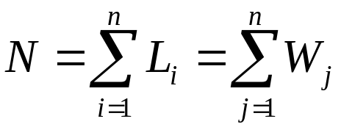). (A)
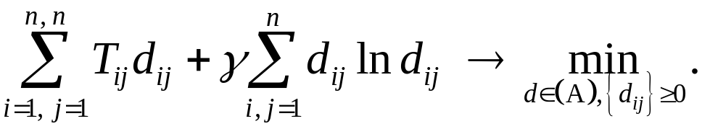
Problem (arising when we build multistage traffic model): 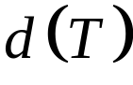 arise in demand matrix calculation model and 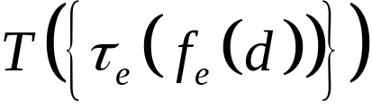, where 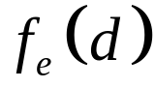 calculated according to BMW (or Stable Dynamic) models. We have vicious circle!
In practice the problem is solved by simple iteration method (equilibrium = fixed point). Though there is no theory (theoretical guarantees) about the convergence of this procedure. We propose new way of rewriting this problem!
Key observation (Demyanov–Danskin’s formula for dual problem):
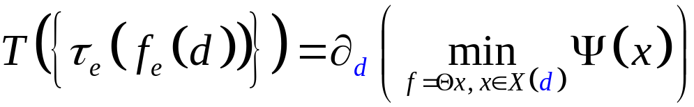 (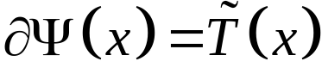, 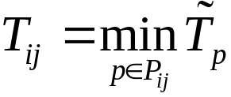).
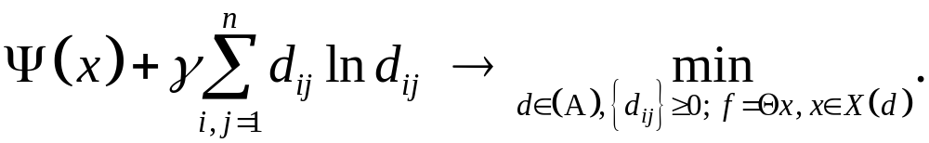
Truss Topology Design
The problem consists in finding the best mechanical structure resisting to an external force with an upper bound for the total weight of construction. Its mathematical formulation can be reduced to LP problem with huge number of affine-type restrictions (dual multipliers here are also important)

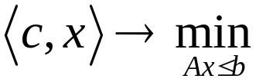.

General property of all mentioned above (and almost all current) huge-scale problem formulations is sparseness of main matrix (or , ). This property sometimes allows to solve huge-scale problems with more than billion variables or restrictions in personal PC.
Note: Term “huge-scale optimization” was introduced by Nesterov Yu. Subgradient methods for huge-scale optimization problems // Math. Program., Ser. A. – 2013. – V. 146. № 1-2. P. 275–297.

To be continued…

